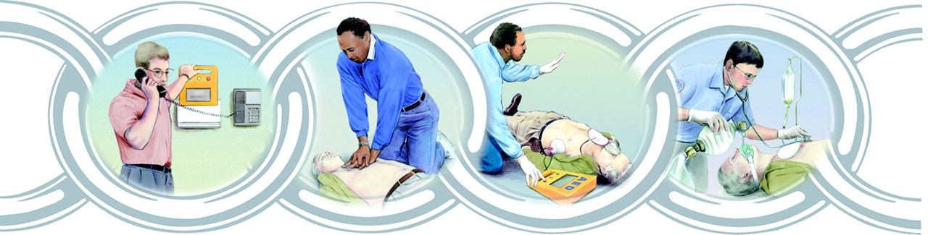

Copyright ©2005 American Heart Association

Executive Summary

Key Largo Volunteer Ambulance Corps responds to 92% of all of their calls in 8 minutes or less with an average response time of 4.64 minutes in 2006. “Researchers in England have concluded that the 8-minute response time is not evidence-based and is putting patients and ambulance crews at risk.” The OPALS study, and others, have noted however, that in Cardiac Arrest cases, a time to defibrillation of 4 minutes or less is the only interval that makes a clinical difference. The Opals study specifically notes that in systems with “optimal rapid defibrillation, advanced life support [ALS] interventions did not improve patient survival.” Without a delay in patient contact, the Corps responded to all cardiac arrest calls within 4 minutes in 2006, meeting the criteria set forth by the OPALS study, However, to increase patient survival from cardiac arrests the Corps specifically recommends:

- Getting more of our community educated trained in First Aid & CPR.
- Getting AED’s back into the community…and creating an awareness program that AED’s save lives.

Chain of Survival for Cardiac Arrest Patients

- Early 911
- Early CPR
- Early Defibrillation (within 4 to 5 minutes)
- Early access to advanced care

Response Times

In a study of 903 ambulance calls in 2006, Key Largo Volunteer Ambulance Corps (the Corps) average response time was 4.64 minutes, beating the surpassing benchmark response time of 8 minutes by 3.36 minutes. In 2006, the Corps responded to 92% of all calls in 8 minutes or less.

Response Times by Mile Marker

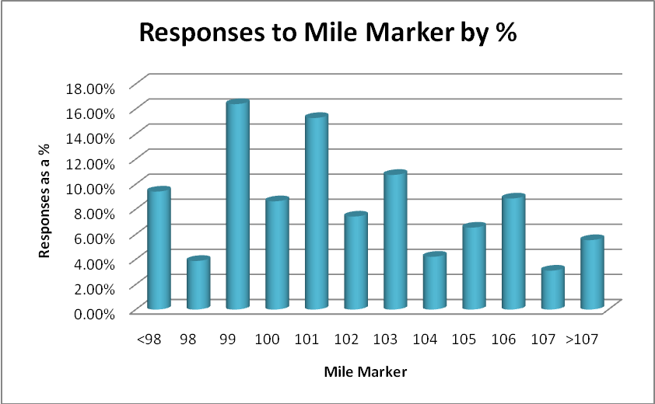
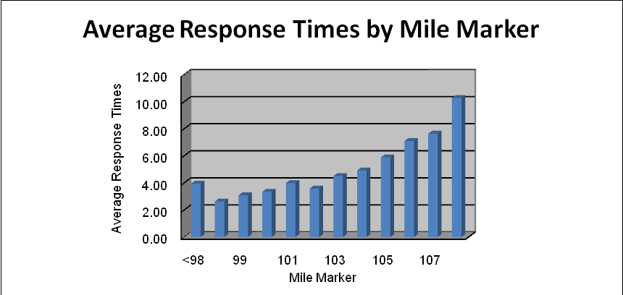
The Corps is able to maintain an average response time of less than 8 minutes to all areas of our district south of mile marker 107.5. (Note: The overwhelming majority of calls above the 107.5 tend to be trauma related calls that require the response of: Key Largo Ambulance Corps, Key Largo Volunteer Fire Department, and/or Miami-Dade and Ocean Reef.) Survival of traumatic arrest is less than 2%.
Calls for service for the Corps below the 107.5 mile marker represent 94.46% of all calls, of which calls below the 103 mile marker represented 61% of all calls for the Corps.

Cardiac Arrests
In 2006, the Corps average response times to patients in cardiac arrest was 3 minutes without a delay in: patient contact or errors in dispatch. In 2006, the Corps responded to 11 cardiac arrest calls, of these calls, 4 were delayed. These delays were caused by:

- Cardiac Arrest on a boat with a prolonged ETA to shore with rescue awaiting the patient at the dock.
- Error by dispatch, prolonging the Corps response to the call.

OPALS Study Findings on ALS
Currently, the Ontario Pre-hospital Advanced Life Support Study (OPALS) is the current gold standard in Sudden Cardiac Arrest studies. Specifically, the OPALS study was broken down into 3 categories of First Aid Response:

- Early CPR
- CPR with Early Defibrillation
- Advanced Life Support (ALS)

The OPALS study found that CPR with Early Defibrillation resulted a significant improvement in survival of sudden cardiac arrest patients. The OPALS study also found that in an EMS system that already has optimal rapid defibrillation, advanced life support interventions did not improve patient survival. Placement of AED’s and community training are the keys to improving patient survival as noted in the OPALS study.

Top 2 Cardiac Arrest Recommendations
- Increase CPR & Advance First Aid training in the Upper Keys
The Corps is working with the community to increase CPR and advanced first aid training. Recently the Corps came to an agreement with Florida Keys Electric Co-Op to train 140 employees in First Aid, CPR, AED and infection control. In 2008, the Corps would like to offer scheduled courses in First Aid, CPR and AED training.
- Get AED’s into the Community
Early defibrillation (in 3-5 minutes) has been shown to specifically increase the chance of survival from sudden cardiac arrest.

Key Largo Volunteer Fire Department: 4 AED’s: one on the Chief’s vehicle, one in the station at station 23, and one AED on a truck at both Station 24 and Station 25.

Monroe County Sheriff’s Office: 0 AED’s in the field. The Sheriff’s Office still trains on AED’s, but no longer carries AED’s in the patrol cars in our district. AED’s typically cost around $1300 each, and the Sheriff’s Office does not have the money in their budget for AED’s. However, if the district could provide 4 AED’s, (one for each Sergeant) the Sheriff’s Office has indicated that they would be happy to carry AED’s in their patrol vehicles.

Florida Highway Patrol: 0 AED’s in our district (bad batteries).

The number of AED’s at hotels, dive boats, charter fishing boats, restaurants, resorts, and attractions is unknown. The Corps has already begun a survey to determine the number of AED’s in our community and areas where the allocation of funds may do the district the most good in AED response. The ideal second tier of survivability starts with this group.

Merginet.com, “Is EMS Response Time a Good Indicator of EMS System Performance/,” Bledsoe, B., Aug. 2007.
Ontario Pre-Hospital Advanced Life Support Study, page. iii. February 2005.
Ontario Pre-Hospital Advanced Life Support Study, page. iii. February 2005.
American Heart Association. “Increased Survival with CPR and AED’s,” www.americanheart.org

