KEY LARGO VOL. FIRE/RESCUE DEPT.
BOARD MEETING OF February 16, 2011

Mike Jenkins called the meeting to order at 7:57 PM in the Day Room at Fire Station #1 in Key Largo, Florida.

In Attendance: President Mike Jenkins, Kandy L. Moore, John Forrer, Bill Meehan, Raymond Barnett, Eric Neitzer, Pedro Marin, Dave Gow, District Board Member Mike Edgerton & Chief Garcia.

Minutes: MOTION by Raymond Barnett & SECOND by Eric Neitzer to accept as posted-OK.

Treasurer’s Report: attached copy- MOTION by Erici Neitzer & SECOND by Pedro Marin to accept the Treasurer’s report-carried.

Membership Committee: Dave Gow: received an application from D Langer & being processed. He brought in 5 yrs. Of applications which were not approved and will give future apps. to Station Manager. We are opening membership again. Frank Ramiriz has been out of the Dept. 2 yrs & will be starting over-did not give a LOA request. Hazel Alzugary is reapplying. MOTION by Raymond Barnett & SECOND by Pedro Marin to accept Ramiriz on 4 mos. probation-carried after discussion.

Functions Committee: Special Detail St Patrick’s Day parade in Delray Beach-need Dept. support & funds to attend-attached request from Honor Guard for a rental car reimbursement for 9 individuals. Discussion: will call Thrifty for a possible better price from Krystal Jenkins-capped the vehicle at $250, lunch, $150 gas for total cap of $605.00.

By-Laws: the committee has proposed the ‘final’ version-discussion followed & certain changes made & will be presented to the next BOD meeting prior to being presented to the General Membership for approval.

New Business: Eric asked why reimbursements take so long-discussed the procedure & that it is actually a lot quicker than in the past. A letter received from Calvary Chapel which meets at the movie house re the need for a Dept. Chaplain-to be read at the General Meeting. Regarding Thursday nites, it is part of the current By-Laws that attendance is required to qualify for reimbursement.
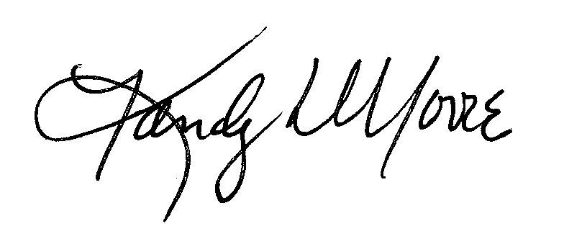
Meeting was adjourned at 10:15 PM.

_____________________________________
Kandy L. Moore, Recording Secretary

